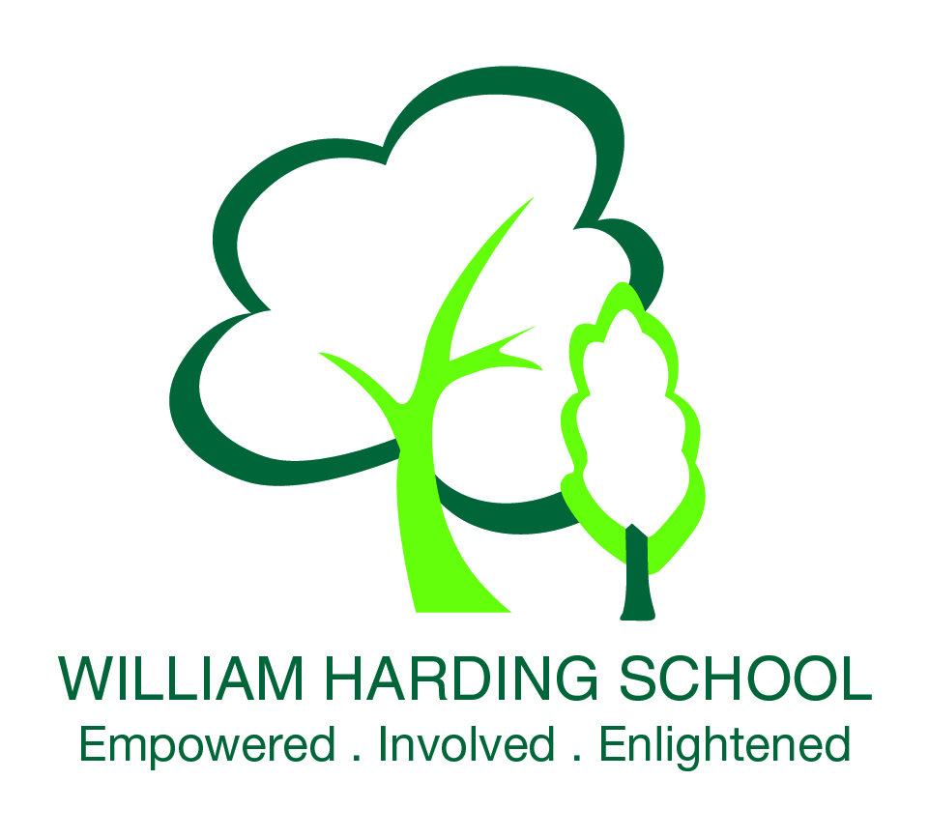

British Values
Promoting British Values at William Harding School
The DfE have recently reinforced the need “to create and enforce a clear and rigorous expectation on all schools to promote the fundamental British values of democracy, the rule of law, individual liberty and mutual respect and tolerance of those with different faiths and beliefs.”
At William Harding Combined School, our ethos revolves around Core Values: Excellence, Respect, Collaboration, Responsibility and Creativity. These are taught through all we do at school and particularly during assemblies and times when we are all together and can learn from each other.
The Core Values determined by the DfE are:
Democracy: Democracy is developed within our school. Pupils have the opportunity to have their voices heard in the classroom (particularly in debates) and Pupil Questionnaires. The elections of representatives on the School Council are based solely on pupil votes. Children have been able to decide on some of the charity events the school has organised and all classes are involved in debates about what it means to be an active citizen using P4C as a means to facilitate these enquiries.
The Rule of Law: The importance of Laws, whether they be those that govern the class, the school, or the country, are consistently reinforced throughout regular school days, as well as when dealing with behaviour, through school assemblies and PSHCE. Pupils are taught the value and reasons behind laws, that they govern and protect us, the responsibilities that this involves and the consequences when laws are broken.
Individual Liberty: Within school, pupils are actively encouraged to make choices, knowing that they are in a safe and supportive environment. As a school we educate and provide boundaries for young pupils to make choices safety, through provision of a safe environment and empowering education. Pupils are encouraged to know, understand and exercise their rights and personal freedoms and advise how to exercise these safely, for example through our E-Safety and PSHE lessons and Assemblies. Whether it be through choice of challenge of how they record, of participation in our numerous extra-curricular clubs and opportunities, pupils are given the freedom to make choices.
Mutual Respect: Part of our school ethos and behaviour policy has revolved around Core Values such as ‘Respect’ and ‘Responsibility’, and pupils have been part of discussions and assemblies related to what this means and how it is shown. We are currently developing our approach to the notion of Rights Respecting Schools which will help the school promote mutual respect even more. We see mutual respect as a fundamental human principle.
Tolerance of those of Different Faiths and Beliefs: This is achieved through enhancing pupils’ understanding of their place in a culturally-diverse society and by giving them opportunities to experience such diversity. Assemblies and discussions involving prejudices and prejudice-based issues have been followed and supported by learning in RE and PSHE. Members of different cultural backgrounds are encouraged to share their knowledge to enhance learning within classes and the school.
The notion of Rights Respecting Schools is being developed within our ethos and curriculum. Our planning is clearly rooted in our core values. We believe our core values are important for the children to learn about. These are linked to a variety of situations which affect themselves in school, at home, in their communities and worldwide. They give the children the opportunity to develop their knowledge of how they can make a difference to others and how everyone is entitled to their rights, explaining how this impacts on our lives.
Our school values are:
- Respect
- Responsibility
- Honesty
- Inclusion
- Collaboration
- Perseverance

