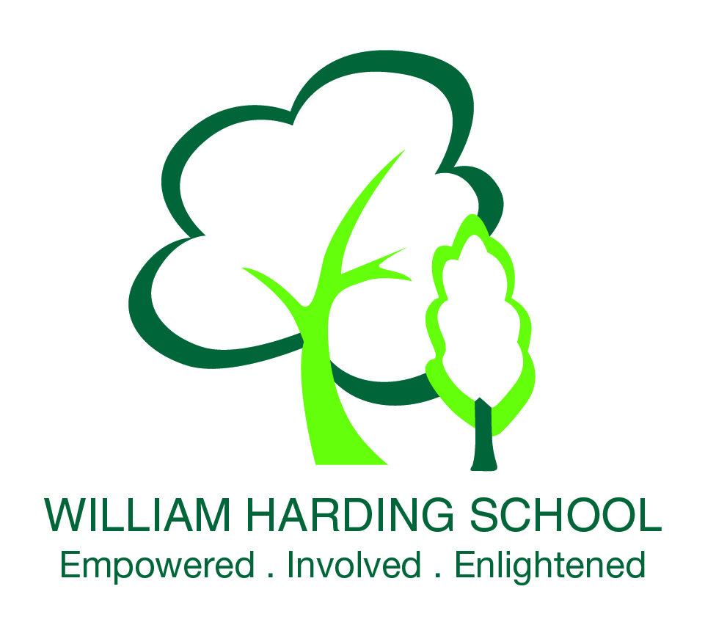
Primary School Curriculum

Spark, Creativity and Thinking
We want children to develop their thinking skills, explore the world around them and acquire a thirst for learning.

The power of stories
The more children read and listen to stories, the more their imagination is sparked and the more they learn how to construct meaningful language. Each day, School 21 children will have the chance to read and hear great stories.

Solving problems, enjoying numbers
We want every child to develop a love of numbers and problem solving from an early age. We want to bring Maths alive so children are grounded in the basics and can use that knowledge to solve real problems.

Learning how to learn
Every child will be taught good learning habits, like how to check their work through and how to stick at it when it gets difficult.

Developing kindness and character
We believe that education is about far more than academic success. It is about becoming kind, optimistic and confident. At School 21, we will develop a school culture that has, at its heart, integrity and humanity.

Science projects
From the moment children start asking questions about the world around them, they are ready for science and ready to discover. At School 21, we will teach science from Reception with exciting projects.

Exploring the world around us
Every term, children will get the chance to work on projects about the world around them that combine knowledge and skills and allow them to ask questions and solve problems.

Sport and movement
Sport makes you fit and healthy, makes your body flexible and helps the brain function properly. We will start each day with exercise.

Thinking and questioning
Children love asking questions when they are young. We want that inquisitive nature to be developed and harnessed so that every child is able to reflect on their learning.

The joy of music
Every child will learn a musical instrument from an early age, all children will be part of a choir and there will be a choice of smaller musical groups.

The magic of art
Art is about exploring shape and form and colour and beauty. It allows the imagination of children to be expressed and makes the school environment vibrant and exciting.

Early years curriculum
Children’s ‘learning and development’ is catered through the Early Years Foundation Stage Curriculum which is made of the seven areas of learning which are:

Communication and language development
Giving children opportunities to experience a rich language environment; to develop their conﬁdence and skills in expressing themselves and to speak and listen in a range of situations.

Physical development
Providing opportunities for young children to be active and interactive and to develop their co-ordination, control, and movement. Children must also be helped to understand the importance of physical activity and to make healthy choices in relation to food.

Personal, social and emotional development
Helping children to develop a positive sense of themselves, and others; to form positive relationships and develop respect for others; to develop social skills and learn how to manage their feelings; to understand appropriate behaviour in groups and to have conﬁdence in their own abilities.

Literacy development
Encouraging children to link sounds and letters and to begin to read and write. Children will be given access to a wide range of reading materials (books, poems, and other written materials) to ignite their interest.

Mathematics
Providing children with opportunities to develop and improve their skills in counting, understanding and using numbers, calculating simple addition and subtraction problems and to describe shapes, spaces, and measures.

Understanding the world
Guiding children to make sense of their physical world and their community through opportunities to explore, observe and ﬁnd out about people, places, technology and the environment

Expressive arts and design
Enabling children to explore and play with a wide range of media and materials as well as providing opportunities and encouragement for sharing their thoughts, ideas and feelings through a variety of activities in art, music, movement, dance, role-play and design and technology.

Modern foreign languages
Children will start to learn a Modern Foreign Language in Reception. They will also get the opportunity to learn dance and music in readiness for learning a musical instrument. Such activities further demonstrate the beneﬁt of the all-through school approach in that the primary and secondary teachers can work collaboratively to provide a very different curriculum to other local schools.

Project Based Learning
In order to add greater depth to a creative curriculum, elements of our curriculum design encourage children to participate in inquiry based projects that work towards the larger goal of answering a central question, solving a problem or meeting a challenge.
The purpose of such activities is for pupils to:
•Engage in a rigorous, extended process of inquiry focused on complex authentic questions and problems
•Work as independently from the teacher as possible, and have some degree of “voice and choice”
•Demonstrate in-depth understanding of academic knowledge and skills
•Build 21st century skills such as collaboration, critical thinking and communication

