Safeguarding and Prevent Strategy
William Harding School is committed to safeguarding and promoting the welfare of children and expects all staff and volunteers to share this commitment.
We have a number of policies and procedures in place that contribute to our safeguarding commitment. Key policy documents can be seen here.
Sometimes we may need to share information and work in partnership with other agencies when there are concerns about a child’s welfare. We will ensure that our concerns about our pupils are discussed with his/her parents/carers first unless we have reason to believe that such a move would be contrary to the child’s welfare.
Our Designated Child Protection Officers are Kerry Lidgett (Deputy Headteacher), Amy Knight (Safeguarding Manager)and Dominic Hughes (Headteacher). Our Safeguarding Governor is Mark Bateman.
sapce
You can find more information about Safeguarding on the NSPCC website here.
space
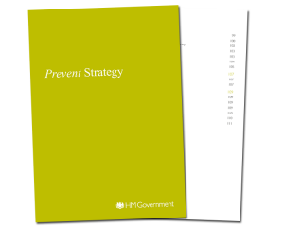PREVENT STRATEGY
As part of William Harding School’s commitment to safeguarding and child protection we fully support the government’s Prevent Strategy. As part of our annual Safeguarding trainings, we ensure that members of our team are aware of governmental priorities. Related issues are now discussed at every Strategic Governing Body meeting.

What is the Prevent Strategy?
The Prevent strategy is a government strategy designed to stop people becoming terrorists or supporting terrorism. As described in official documents published by Her Majesty’s Government, the Prevent Strategy:
- responds to the ideological challenge we face from terrorism and aspects of extremism, and the threat we face from those who promote these views
- provides practical help to prevent people from being drawn into terrorism and ensure they are given appropriate advice and support
- works with a wide range of sectors (including education, criminal justice, faith, charities, online and health)
space
If you are concerned that a Governor or potential Governor may have links to extremism or that child might be at risk of extremism, or if you have any other concern about extremism at William Harding School, please contact the Department for Education’s helpline on counter.extremism@education.gsi.gov.uk or 020 7340 7264. Parents/carers can also find some more information on the Educate Against Hate website by the DfE: click here.
space

