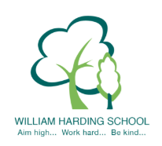

Year 1 Pupil Voice meeting with the IPSL May 2021
What are the school values?
Be kind, show respect, keep trying, work together, be honest, be inclusive. The children could name all of our values.
What do the school values mean?
Including others and ask them to play. Be kind to everyone. The school values help us learn and help us behave well. They help us listen to others. They help make us good people.
What is SMSC?
Social, moral, spiritual and cultural values.
What does spiritual means?
Thinking about other faiths and beliefs.
What does moral mean?
Knowing right and wrong.
What does social mean?
Social distances now. It is about keeping everyone safe and helping someone.
What does cultural mean?
Knowing about other people’s lives and beliefs. Showing respect for others.
What are British Values?
Democracy, Rule of Law, Individual Liberty, Mutual Respect and Tolerance of faiths and beliefs. We have them to help us to be kind and safe. If we follow them we will be happy. These make people better people. If we follow these we can be proud of ourselves.
What does democracy mean?
Voting and choosing.
What does rule of law mean?
Listen to the rules and following them.
What does individual liberty mean?
Making choices for yourself.
What does mutual respect mean?
Being kind to everyone.
What does Tolerance of faiths mean?
Knowing about lots of faiths and beliefs

