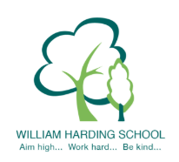

Year 2 Pupil Voice with the Headteacher December 2019
- they were clear about they feel safe with good examples; people, friends, teachers who help us and no unkind people
- they were proud of their writing, as they have good handwriting and write a lot
- they were proud of their independent science work
- they enjoy learning, as it helps them learn more and helps them in tests and they learn something new
- they know clearly how to improve their learning and said they ‘use the things we have learnt, the teacher does some on the wall and we use these, you can look on the board and include what our teacher tells us’
- they were able to talk about next steps as it tells them what to do, ‘there are green triangles and we stick them in and we answer at the beginning of the lesson in red pen’
- with progress they said that now it is easy and ‘now I can do arrays, I can do the next steps now, division, joining up and capitals’
- LO tells you what you are doing and the SC ‘tells us which table is doing which, we use green and orange pencils to dot what we can do’
- they were able to say what helps them learn; displays, maps, look in your book, dienes, counters and no line
- they have opportunities to learn independently
- talked about the red C for challenge and the challenge stickers
- they were able to name all the School Values
- they said the following were great at our school; teachers having fun, lots of learning, gems, star of the week as we are proud of ourselves, we follow the school values, teachers help us when we are late to get to class

