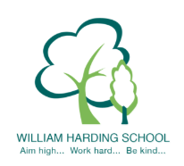

Year 2 Pupil Voice meeting with the Headteacher October 2021

What would you tell a visitor about WH, what is it like to be a pupil here?
Really great to be here, great school because learn new and fun activities, learn how to keep safe.
What can you tell me about behaviour at WH? (good/dealt with well/support)
Great, good so we can play, good because they do the right thing, some a bit naughty – told off, might not know how to be kind.
What are you proud of at William Harding?
Our work, things we have learnt, of our teachers because they teach us.
How are you challenged?
Getting onto yellow Success Criteria, hard work, challenge – on board – red pen challenge.
What is great about the school?
Lunch time, lots of lessons, learn more things, you can try, enrichment time, learn, star of the week, great because reward time.

