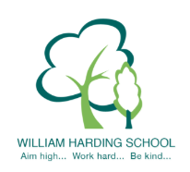

Year 3 Pupil Voice with the Headteacher November 2019
- they all feel very safe - adults, gates, children support each other, fire procedures, teachers are kind and helpful and they can share their worries
- they are very proud of their writing and could articulate why
- they enjoy learning because it helps them and when they are older they can remember who has helped them to get a good job with lots of money, they can tell their families what they have learnt, it will help them be really smart and all the knowledge will help people be astonished by you
- they know how to improve as they have the next step stickers with red pen answers, they talked about the blue, green and yellow and how that helps them
- they knew their next steps and read these out from their books and this was across a range of subjects
- they showed the progress they made and one pupil said they now use "" and another said they use a dictionary better, another is using adjectives now
- they said the LO tells you what to do and helps you know what to do in each subject and SC also helps you know what to do and you can self assess
- they said they learn from the specific reading books and do work around the books and read and write about it
- they could articulate very well what helps them learn - teachers, teaching assistants, resources, next steps, pupils, reading records, writing from other books, their brains and displays
- pupils could say how they learn independently every day
- they talked about the challenges of red C
- they were very good at sharing the School Values and why we have them
- They shared what is great about the school - teachers help you learn, reading, partners help us, lots of resources and teachers are kind and helpful, everyone is kind

