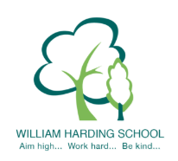

Year 3 Pupil Voice meeting with the Headteacher April 2021

What would you tell a visitor about WH, what is it like to be a pupil here?
Great school, everyone is kind, fun lessons. It is safe.
Tell me about School Values, SMSC & BV.
Respect, honesty, perseverance, collaboration, inclusion, Spiritual, cultural, moral and social. Kindness, democracy, Individual Liberty, Mutual Respect. Really important. We need to respect others to get be kind award, gems, perseverance
How do you improve your learning?
Make it better and better. Carry on and don’t give up.
Tell me about reading at WH
Definitely improved reading, teachers help to sound out. It’s fun.
More you read, the more you’ll travel. RWI helps you read
Do you feel safe at WH?
Yes. Cameras, staff everywhere with lanyards. Fire alarms.

