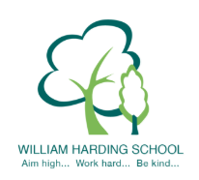
Year 3 Pupil Voice meeting with the HT May 2021
Tell me about reading at WH?
Reading is good as we have skilled books to help us get to the next level - it is fun and relaxing. It is important.
What can you tell me about behaviour at WH?
Most people are kind and nice and if they aren't they get told off and that stops it.
Why do you enjoy learning?
Lessons are fun and I love drawing in art.
Do you feel safe?
Yes, teachers make me safe and my friends. I tell a teacher if I am worried.
What are your next steps in learning?
They help move on our learning because they are challenges for the next steps and we do them at the start of the next lesson.
Tell me about School Values and BV?
BV stands for British Values. Our School Values are all around us and are used anywhere - they help us learn. We respect and share things. We know all the BV and School Values!
What is great about the school?
There are kind friends and the teachers do nice things for us and help us.
Tell me about play and lunch?
We get to have fun and teachers keep us safe. We get to have lots of playtime and we run about.

