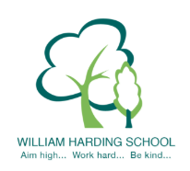

Year 4 Pupil Voice meeting with the HT Nov 2019
- they all definitely feel safe
- they are proud of their handwriting and extended writing
- they are happy and enjoy learning
- they know how to improve their learning and can articulate their next steps
- they could talk about the LO and SC and how it helps them learn and know what to do
- they could say what and who helps them learn
- they said they have opportunities to learn independently all the time
- they feel they are being challenged by the red C
- they could articulate the School Values
- their books were very well presented
- they said many things were great about the school; lots of teachers, good rewards, everyone respects each other, gates to keep us safe, fun lessons, cleaners to keep our environment clean, lots of kind children

