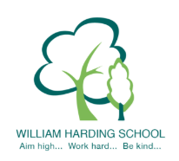

Year 4 Pupil Voice meeting with the Headteacher September 2021

What would you tell a visitor about WH, what is it like to be a pupil here?
Amazing, teachers keep us safe, nice friends, teachers organised for learning, everyone cares for you, welcomed.
Do you feel safe at William Harding?
Yes! Gates, cameras, teachers, Flo team, protected, walkie talkies, keys, hand sanitizer, fire practices – know what to do.
What are your next steps in learning?
Move on our learning, write triangle respond/answer, red pen.
Tell me about Learning Objectives/Success Criteria
Learning Objective tells you what you learn. Success Criteria tells you what to do
What helps you to learn (including environment, resources, TAs)
Posters, challenge stickers, flip charts, paper/sheets, lead learners, resources, teacher examples on board, counters, X tables.
How are you challenged?
On green challenge go on other colours, on walls eg Maths challenge stickers Challenge in books, red pen
Tell me about the WH knowledge curriculum and knowledge organiser
Vocabulary, test what you don’t know and teach, cold, hot task
What is great about the school?
Good school to be in, nice members of staff, clubs – so many – netball, martial arts, learn new things, nice lessons, safe, lots of learning

