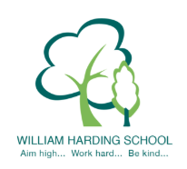
Year 5 Pupil Voice meeting with the HT April 2021
What are you proud of at WH?
I am proud of my Science extended writing, I understood it and really enjoyed it. I have and use key vocab and we use the VGPS (Vocabulary, Grammar, Punctuation and Spelling) to help us.
Tell me about Reading at WH?
We have SQUIRT; Super Quality Uninterrupted Reading Time, we read a book each term and answer questions and learn new skills. We skim and scan and then we write in our books. We do retrieval, inference and prosody.
How are you challenged?
We do PIXL catch up and warm ups, we also have next steps we need to do. We have C's in our books for our challenges.
What helps you learn?
We have boards for English, maths, science and others which help us, they have previous work on we have learnt. The teacher and the TAs also help us as do our partners.
What is it like to be a pupil at WH?
Everything is fun, we always get help learning and have learning resources. Teachers are nice and they help us.
Do you feel safe at WH?
Yes, we have gates, walkie talkies for any problems, there is always a teacher about, badges so we know who the staff are. We have lockdown practices in case of a rude or bad person is here.
Tell me about the learning objective and success criteria?
The LO is what we are learning and the SC is what you are going to be doing. I am blue so I do work for the blue group and then I can do a challenge - this is either a C in the margin or a challenge sticker.

