Knowledge Organiser- Spatial Sense (Geography- Year 6)

Key Vocabulary | Definition
Longitude | Imaginary lines parallel to the prime meridian line that help map makers locate places with accuracy. (Vertical lines)
Latitude | Imaginary lines parallel to the equator that help map makers to locate places with accuracy. (Horizontal lines)
Axis | An imaginary line around which the Earth rotates.
The Poles | The two locations on the surface of the Earth that are at the Northern and Southern ends of the axis of rotation.
Tropic of Cancer | The line of latitude 23° north of the equator.
Tropic of Capricorn | The line of latitude 23°south of the equator.
Prime Meridian | The line of longitude at 0°.
Time Zone | A range of longitude that shares a common time.
Map Projection | A method that represents the Earth on a flat surface.

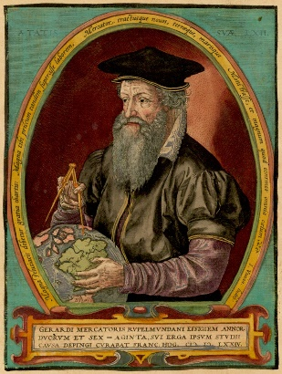

Gerhardus Mercator
Flemish Cartographer
Projected the Earth onto a flat surface in the 1500s.

