Key Vocabulary | Definition
Circulatory system | Bodily system made up of the heart, blood vessels and blood that delivers essential materials to cells whilst removing waste products
Transport | The circulatory system transports nutrients (from digested food) and water to every cell as well as oxygen
Atria | The plural of ‘atrium’. The upper chambers of the heart
Ventricles | The lower chambers of the heart
Valves | Found between the atria and ventricles they open and close to allow the blood to flow through the heart
Aorta | The largest artery supplying oxygenated blood to the rest of the body
Arteries | Carry blood with oxygen from heart
Veins | Carry blood depleted of oxygen back to heart
Capillaries | Tiny vessels where oxygen gets transferred to cells
Pulse rate | The number of heart beats per minute
Knowledge Organiser- Science Year 6- Circulation
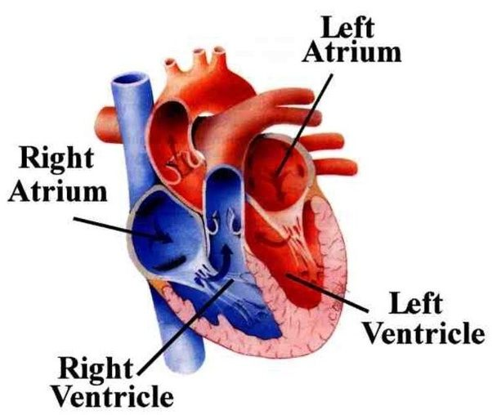

Blood Vessels
Arteries | Veins | Capillaries
- Carry blood away from the heart  - Oxygenated blood | - Carry blood back to the heart  - Deoxygenated blood | - Transfers oxygen from the blood stream to other tissues in the body

Components of Human Blood
Red Blood Cells | White Blood Cells | Platelets
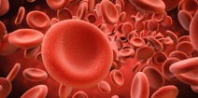  Haemoglobin is the red protein found in red blood cells that transport oxygen around the body | 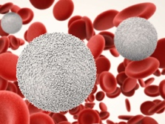  A part of our immune system. Helps the body to fight infections | 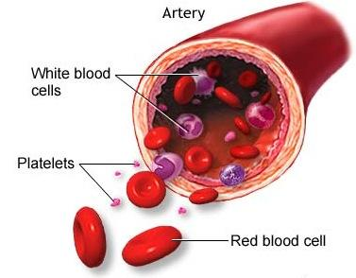  Tiny blood cells that help your body to form clots to stop bleeding

