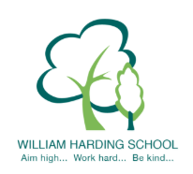

Year 6 Pupil Voice meeting with the HT Nov 2019
- feel safe because of the staff, fire practices, lock downs and fencing
- were proud of their writing and editing
- enjoy learning
- know clearly how to improve their learning and the next steps needed
- know why we have LO/SC stickers and how they support their learning
- knew what SQUIRT meant and what it looked like in each lesson
- were challenged and used the red C
- knew the School Values and why we have them
- thought the following were great at our school; teachers, IWB, safe, PE equipment, LO stickers, play area/field, safe classrooms, new book cases, displays to help with learning

